State Flags—examples of symbolism

 |  | Diamond | Small but valuable (Delaware)
 |  | The color BLUE | Loyalty and justice (Pennsylvania, Wyoming, and US Flag); Sky (Alaska, Wyoming)  Almost half of the state flags have a blue field.
 |  | Olive Branch | Peace (Pennsylvania, Oklahoma)
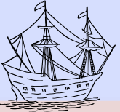 |  | Ship | Commerce (Pennsylvania)
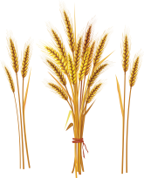 |  | Sheaf of Wheat | Agriculture (Pennsylvania)
 |  | Liberty Cap | Liberty (New Jersey and others-originally a “Phrygian cap” given by Romans to freed slaves)
 |  | Cornucopia | Agriculture (New Jersey)
 |  | The colors dark blue and buff | George Washington’s uniform (Delaware, New Jersey, New York)
 |  | Grapevine with fruit | Transplanted people growing strong in their new home (Connecticut)
 |  | Arrow pointing down | Peace (Massachusetts)
 |  | Arrow pointing up | War (Michigan)
 |  | Scales | Everyone should receive equal treatment under the law (New York)
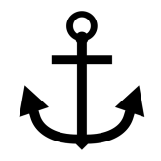 |  | Anchor | Coastline (Rhode Island)
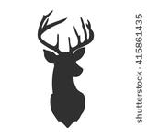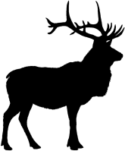 |  | Animals | Some flags show state birds or other animals that are abundant in the area. (Delaware, Vermont, Louisiana, Maine, Wisconsin)
 |  | Stars | Represent original colonies of the nation (Georgia, Ohio) or distinct geographical areas of the state (Tennessee), or number of states in the union when that state was admitted (Arkansas, Oregon, Nevada). One single star represents independence (Texas)
 |  | Torch | Enlightenment and Liberty (Indiana)
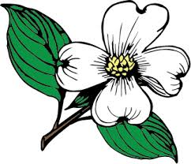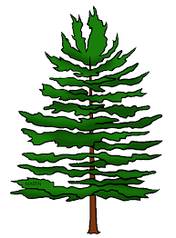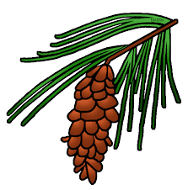 |  | Trees or flowers | Abundant in the state or symbolic of a story associated with the state (Mississippi, Ohio, Maine, Minnesota)
North Carolina |  | Name of the State | To help outsiders identify the flag (Illinois, Wisconsin)
 |  | Cloud | Difficulty (Missouri)
 |  | Bears | Courage; strength and bravery (Missouri, California); Alaska references Ursa Major, the Great Bear constellation
 |  | Crescent Moon | Small now, but full of potential (Missouri)
 |  | Eagle | United States (Michigan, Illinois)
 |  | Boulder | Strength (West Virginia)
 |  | The color white | Purity and uprightness (Wyoming)
 |  | The Color Red | Blood of the pioneers (Wyoming)
 |  | Beehive | Commerce and hard work (Utah)
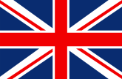  Scotland England  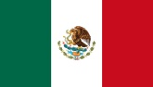  Mexico Ireland |  | Flags of Other Countries | Shows respect for countries whose people settled it as pioneers (Hawaii; Missouri, Iowa)

